**ANALYSIS OF MANGROVES IN GUJARAT USING**

**DATACUBE**

* **VANAMALA SRINITH**

**TABLE OF CONTENTS**

**CHAPTERS**

**ABSTRACT**

**1. INTRODUCTION**

**2. ANALYSIS**

**3. METHODOLOGY**

**4. DESIGN**

**5. FLASK APPLICATION**

**6. UI**

**7. SCREENSHOTS**

**8. CONCLUSION**

**9. BIBLIOGRAPHY**

**ABSTRACT**

**1. Introduction:**

Mangroves, vital coastal ecosystems, face threats from human activities and climate change. Understanding their dynamics is crucial for conservation. This project uses satellite data to analyze mangrove health and changes over time, providing valuable insights.

**2. Existing System:**

Previous studies used remote sensing techniques but did not extensively utilize DataCube technology.

**3. Proposed System:**

This project aims to leverage DataCube technology for enhanced mangrove analysis in Gujarat, involving satellite imagery acquisition, pre-processing tasks, and mangrove classification and analysis.

**4. Technologies and Approaches:**

1. Remote Sensing: Acquire relevant data on mangrove areas

2. Data Cube: Efficiently store and retrieve satellite data for analysis

3. Machine Learning: Analyze data and predict changes

4. Flask: Develop user-friendly web applications for data access and visualization.

5. Web Development:HTML,CSS and JavaScript.

**5. Hardware Requirements:**

Processor: INTEL i3 processor

Primary Memory: 4 GB RAM

Hard Disk: 1 TB HDD

**6. Software Requirements:**

Front End: HTML,CSS, Javascript

Back End: Flask

Database: Postgres

**1. INTRODUCTION**

The project focuses on analyzing mangroves in the state of Gujarat, India, using DataCube technology. Mangroves are vital coastal ecosystems characterized by dense vegetation and high ecological significance. They provide numerous benefits, including coastal protection, carbon sequestration, and habitat for diverse species. However, mangroves are under increasing threat from human activities and climate change. Therefore, it is crucial to monitor and understand their status, dynamics, and environmental relationships to effectively conserve these valuable ecosystems.

**Purpose of this document:**

This project aims to analyze mangroves in Gujarat, India, using a data cube for efficient data management and analysis. Focused on understanding changes in mangrove area over time, the research aims to support evidence-based conservation efforts and sustainable management practices to protect these critical coastal ecosystems from increasing pressures due to human activities and environmental changes.

**Scope:**

The project's scope includes monitoring and analyzing temporal variations in mangrove coverage in Gujarat. Utilizing remote sensing data and advanced analysis techniques, the research will track the expansion or contraction of mangrove areas and explore the underlying factors influencing these changes. The insights gained will aid informed decision-making and conservation planning.

**Overview:**

Leveraging remote sensing data and data cube technology, this project will efficiently manage and process satellite data related to mangrove areas in Gujarat. By focusing on changes in mangrove area, the analysis will provide valuable insights into the dynamic nature of these coastal ecosystems. The outcomes will empower stakeholders to make informed decisions, promoting the preservation and sustainable management of Gujarat's mangroves amidst environmental challenges.

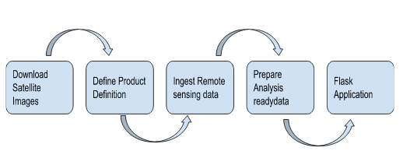

**2. ANALYSIS**

**2.1 Scope and analysis of the system**

The "Analysis of Mangroves in Gujarat Using DataCube" project aims to study and assess the mangrove ecosystems in Gujarat, India. The project's scope includes acquiring high-resolution satellite imagery of the study area, preprocessing the data to enhance its accuracy, conducting image classification to map mangrove areas, and detecting temporal changes in mangrove cover. The analysis will also explore the relationships between mangrove distribution and environmental variables such as water salinity and sediment characteristics. By employing DataCube technology, the project will efficiently process and analyze large volumes of data. The analysis results will provide valuable insights into the spatial distribution, dynamics, and ecological requirements of mangroves in Gujarat, supporting informed decision-making for conservation and management efforts.

**2.2 Existing System and Proposed System**

**Existing System**

The existing system for analyzing mangroves in Gujarat relies primarily on manual methods and limited data sources. Traditional field surveys and manual interpretation of satellite imagery are time-consuming and labor-intensive processes. These methods often provide only limited spatial coverage and are prone to human errors and biases. Additionally, the existing system lacks the ability to effectively analyze and integrate large volumes of data, hindering comprehensive understanding of mangrove ecosystems and their dynamics.

**Proposed System**

The proposed system, "Analysis of Mangroves in Gujarat Using DataCube," aims to overcome the limitations of the existing system by leveraging advanced technologies and data analysis techniques. The project proposes the use of high-resolution satellite imagery, remote sensing data, and DataCube technology to efficiently process and analyze large volumes of data. The proposed system includes preprocessing techniques to enhance data accuracy, image classification algorithms to map mangrove areas, and temporal analysis methods to detect changes in mangrove cover over time. By integrating various data sources and employing automated analysis techniques, the proposed system will provide a more comprehensive and accurate understanding of the mangrove ecosystems in Gujarat. This will enable better decision-making for conservation, management, and policy planning related to the mangrove forests in the region.

**2.3 Requirement Specification**

**Hardware Requirements:**

Processor: INTEL i3 processor

Primary Memory: 4 GB RAM

Hard Disk: 1 TB HDD

**Software Requirements:**

Front End: HTML,CSS, Javascript

Back End: Flask

Database: Postgres

**2.4 Technologies**

**1. Data Cube:**

Building a data cube for efficient storage and retrieval of vast volumes of satellite data related to mangrove areas and characteristics.

**2. Remote Sensing:**

Utilizing remote sensing technology to acquire relevant data on mangrove areas and characteristics.

**3. Machine Learning:**

Implementing advanced machine learning algorithms for data analysis and prediction of changes in mangroves.

**4. Flask:**

Developing user-friendly web applications using Flask, a micro web framework in Python, for data access, visualization, and analysis.

**5. Web Development:**

Employing HTML, CSS, and JavaScript to create interactive interfaces for users to access and explore data.

**2.5 Technical Requirements**

The technical requirements for an Earth Observatory Data Cube project will vary depending on the specific needs and requirements of the project. However, some common technical requirements for such a project might include:

**1. Data storage:**

A large and scalable data storage solution is needed to store the remote sensing data and other data used in the project.

**2. Data processing:**

A robust data processing infrastructure is needed to process the large volumes of remote sensing data, including image processing, data analysis, and data modeling.

**3. Software tools:**

A suite of software tools is needed to manage, process, and analyze the data, including tools for data visualization, data analysis, and data modeling.

**4. Computational resources:**

Adequate computational resources are needed to process the large volumes of data, including high-performance computing (HPC) systems or cloud computing resources.

**5. Network infrastructure:**

A reliable and high-speed network infrastructure is needed to transfer the data between the data storage, processing, and analysis systems.

**6. Technical support:**

Adequate technical support is needed to ensure the smooth operation and maintenance of the project's technical infrastructure, including software and hardware support.

**7. Data security:**

Appropriate data security measures are needed to protect the sensitive remote sensing data and other data used in the project.

**3. METHODOLOGY**

**REMOTE SENSING**

Remote sensing is the process of collecting information about the Earth's surface, atmosphere, and oceans from a distance using various sensors mounted on satellites, aircraft, drones, or ground-based platforms. It allows us to observe and gather data about large areas of the Earth without direct physical contact.

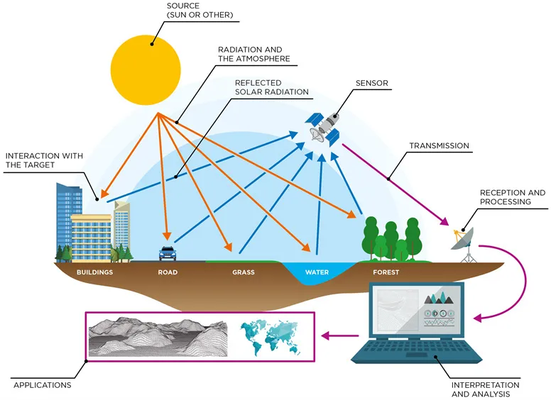

*Sentinel* and *Landsat* are two prominent satellite missions that are widely used for remote sensing:

**SENTINEL**

Sentinel-2A and Sentinel-2B are part of the European Space Agency's (ESA) Copernicus program, a global Earth observation initiative aimed at monitoring the environment and providing valuable data for various applications. Both satellites are designed to provide high-resolution optical imagery of the Earth's surface, offering detailed insights into land cover, vegetation, and natural phenomena.

Here is some information about Sentinel-2A and Sentinel-2B:

1. Sentinel-2A:

- Launch Date: Sentinel-2A was launched on June 23, 2015, from Kourou, French Guiana.

- Orbit: Both Sentinel-2A and Sentinel-2B are placed in a polar sun-synchronous orbit at an altitude of approximately 786 kilometers.

- Sensor: Sentinel-2A is equipped with the Multispectral Instrument (MSI), which captures imagery in 13 spectral bands. These bands range from visible and near-infrared to shortwave infrared, allowing for comprehensive land cover analysis.

- Spatial Resolution: The spatial resolution of Sentinel-2A imagery varies from 10 meters to 60 meters, depending on the spectral band.

- Revisit Time: Sentinel-2A provides global coverage every five days, allowing for frequent monitoring of changes on the Earth's surface.

2. Sentinel-2B:

- Launch Date: Sentinel-2B was launched on March 7, 2017, from Kourou, French Guiana.

- Sensor: Similar to Sentinel-2A, Sentinel-2B is equipped with the Multispectral Instrument (MSI), providing the same 13 spectral bands and spatial resolution.

- Orbit and Revisit Time: Sentinel-2B orbits the Earth in synchronization with Sentinel-2A, ensuring a five-day revisit time and global coverage.

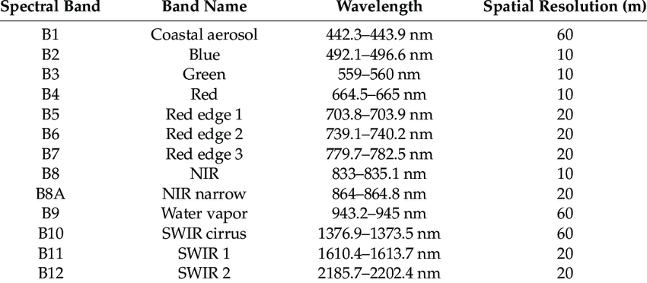

**LANDSAT**

Landsat is a series of Earth-observing satellites operated by the United States Geological Survey (USGS) in partnership with NASA (National Aeronautics and Space Administration). It is one of the longest-running and most successful satellite programs for Earth observation and remote sensing. The Landsat program has been instrumental in providing continuous and valuable data about the Earth's surface for over four decades.

Key features of the Landsat program:

1. History and Launch:

- The first Landsat satellite, Landsat 1, was launched on July 23, 1972, marking the beginning of the program.

- Since then, several Landsat satellites have been launched, with each successive mission incorporating advancements in technology and sensor capabilities.

2. Sensors:

- The primary sensor on Landsat satellites is the Thematic Mapper (TM) or the Operational Land Imager (OLI), depending on the mission.

- These sensors capture images in multiple spectral bands, including visible, near-infrared, shortwave infrared, and thermal infrared.

- The spectral information obtained from these sensors allows for detailed analysis of land cover, vegetation, water bodies, and other features on the Earth's surface.

3. Spatial Resolution and Coverage:

- Landsat imagery has varying spatial resolutions, depending on the sensor and the mission. The TM sensor provides a spatial resolution of 30 meters, while the OLI sensor offers 30-meter and 15-meter resolutions for some bands.

- The wide swath of the sensors enables Landsat satellites to cover a significant area during each pass, making them well-suited for large-scale environmental monitoring.

4. Revisit Time:

- The Landsat satellites are placed in a sun-synchronous orbit, allowing them to cover the entire Earth's surface every 16 days.

- This relatively short revisit time provides frequent opportunities for monitoring changes in land cover and land use over time.

5. Open Data Policy:

- Landsat data is freely available to the public, making it a valuable resource for researchers, governments, and organizations worldwide.

- The open data policy has facilitated numerous scientific studies, environmental monitoring efforts, and land management applications.

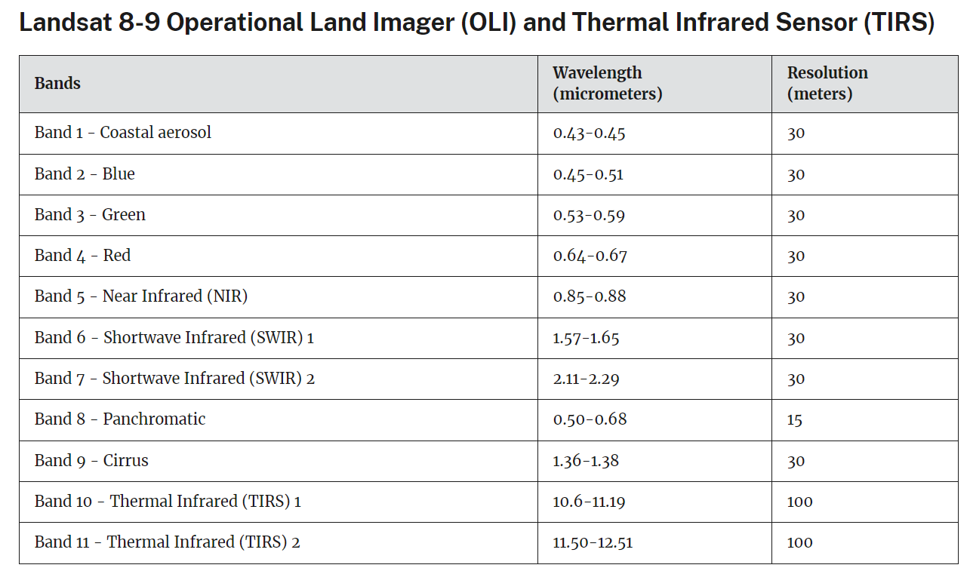

**BAND COMBINATIONS**

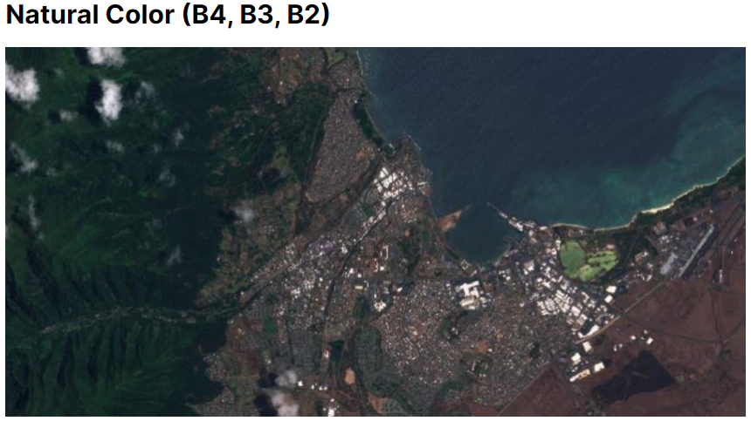

Its purpose is to display imagery the same way our eyes see the world.

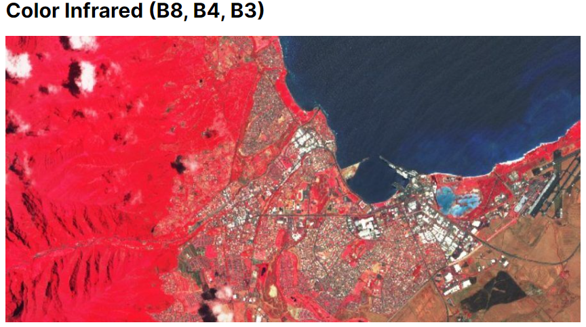

Meant to emphasize healthy and unhealthy vegetation.good at reflecting chlorophyll, denser vegetation is red, urban areas are white.

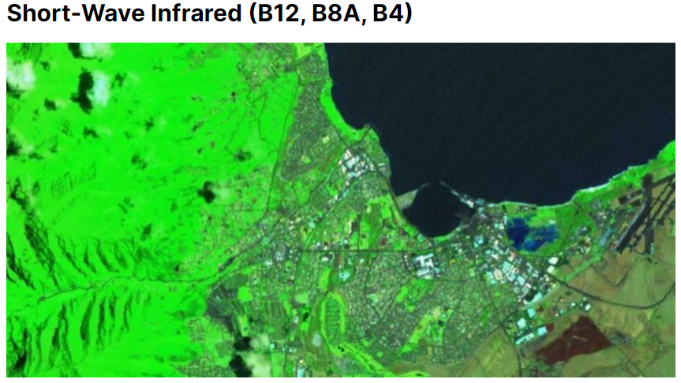

Shows vegetation in various shades of green.darker green indicate denser

vegetation,brown is indicative of bare soil & built-up areas.

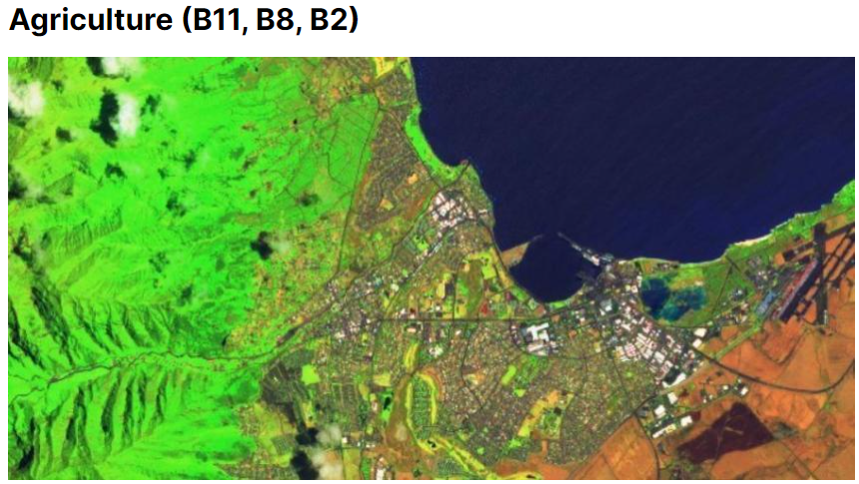

Mostly used to monitor the health of crops.B11 & B8 are good at highlighting dense vegetation that appears as dark green.

**QGIS**

QGIS is a free and open-source geographic information system (GIS) software used for viewing, editing, analyzing, and visualizing geospatial data. It provides a user-friendly platform for various applications in geography, environmental science, urban planning, and more.

Remote sensing data, when processed and analyzed using GIS software like QGIS, allows us to perform various tasks, including visualization and calculations of indices like NDVI (Normalized Difference Vegetation Index) and EVI (Enhanced Vegetation Index). Here's how QGIS facilitates these tasks:

1. Visualization of Remote Sensing Data:

- QGIS allows us to load and visualize remote sensing data, such as satellite imagery captured by sensors like Landsat or Sentinel.

- We can explore and display different bands of the imagery, such as visible, near-infrared, and thermal bands, to gain insights into land cover, vegetation, water bodies, and more.

- QGIS provides tools for adjusting image contrast, color compositing, and creating false-color composites for enhanced visualization.

2. NDVI and EVI Calculation:

- NDVI and EVI are widely used vegetation indices derived from remote sensing data to assess vegetation health and density.

- With QGIS, you can calculate NDVI and EVI using the formula:

NDVI = (NIR - Red) / (NIR + Red)

EVI = 2.5 * ((NIR - Red) / (NIR + 6 * Red - 7.5 * Blue + 1))

- QGIS allows you to extract the required bands (e.g., near-infrared, red, blue) from the satellite imagery and apply the formulas to generate NDVI and EVI raster layers.

3. Raster Calculations and Map Algebra:

- Apart from NDVI and EVI, we can perform various raster calculations and map algebra operations in QGIS.

- These operations include combining, subtracting, multiplying, and dividing raster layers to create new data products and derive meaningful information.

4. Spatial Analysis and GIS Tools:

- QGIS provides a wide range of spatial analysis tools that complement the processing and analysis of remote sensing data.

- We can perform various analyses, such as overlay operations, proximity analysis, terrain analysis, and suitability modeling.

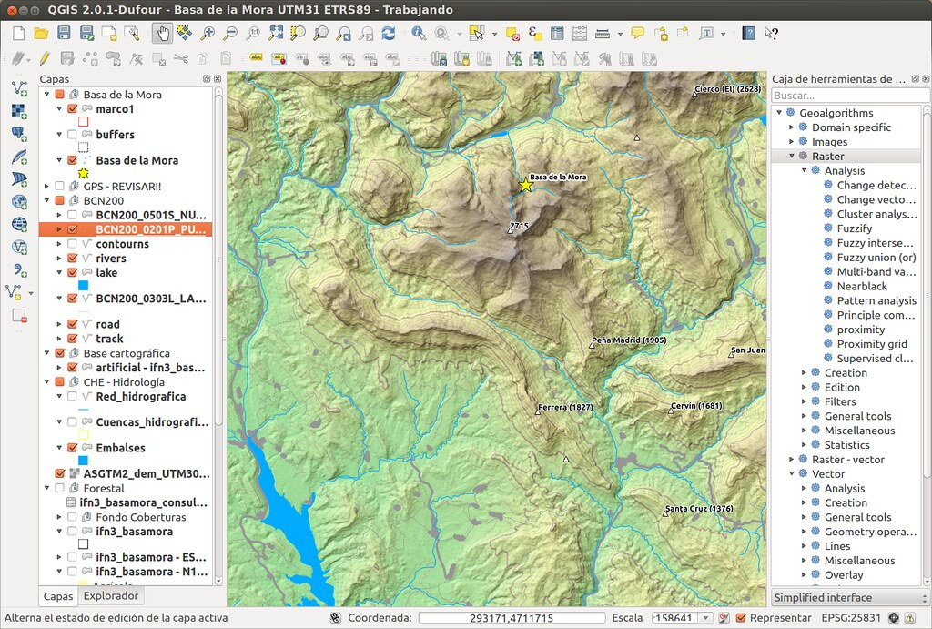

**DATACUBE**

A data cube is a multidimensional representation of data used in various fields, including remote sensing, GIS, and data analysis. It organizes data in a three-dimensional or higher-dimensional structure, allowing for efficient storage, retrieval, and analysis of large volumes of data.

A data cube that typically represents spatiotemporal data, where the dimensions correspond to:

1. Spatial Dimensions: Representing the geographic location of the data, such as latitude and longitude or x, y coordinates on a map.

2. Temporal Dimension: Representing time, allowing data to be organized and analyzed over different time intervals, such as days, months, or years.

3. Spectral or Band Dimension: Representing different spectral bands or channels captured by remote sensing sensors, such as visible, near-infrared, or thermal bands.

A data cube efficiently stores and manages remote sensing data acquired over time, providing a comprehensive spatiotemporal representation of the Earth's surface. It enables users to perform complex analyses, such as change detection, land cover classification, and monitoring environmental trends over time.

Data cubes are valuable tools for handling large and continuous streams of data, making them particularly useful in applications where a temporal perspective is crucial, such as monitoring land cover changes, vegetation dynamics, weather patterns, and urban growth. The ability to organize data in a data cube format facilitates data exploration and advanced analytics, enhancing our understanding of complex spatiotemporal phenomena.

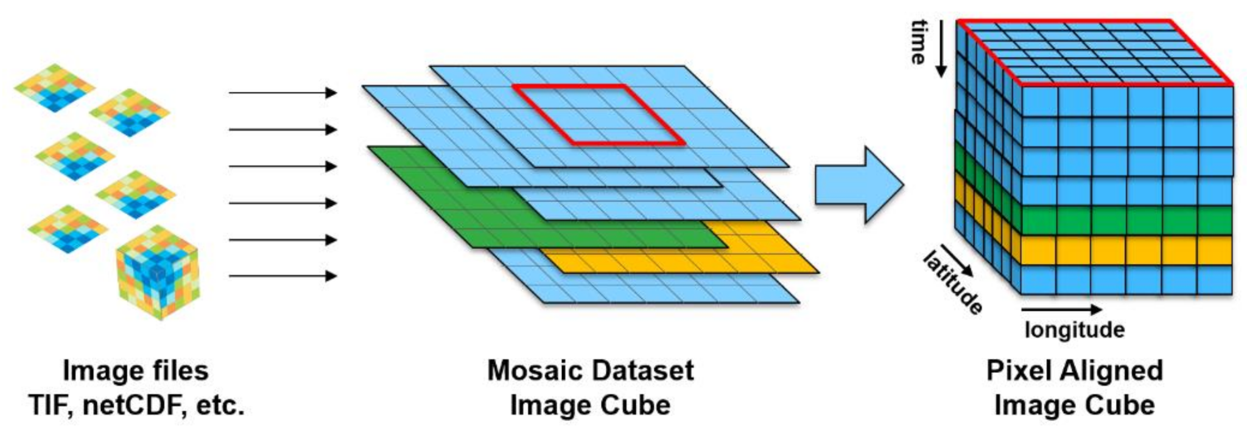

**ODC(OPEN DATACUBE)**

The Open Data Cube (ODC) is an open-source software platform for managing and analyzing large volumes of satellite data. It supports various satellite sensors like Landsat, Sentinel, and MODIS. ODC enables efficient data access, advanced analysis (e.g., change detection, time series), and application in land use planning, disaster response, and environmental monitoring.

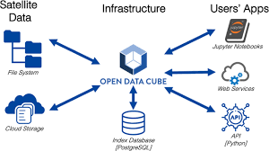

**VEGETATION INDICES**

**NDVI**

NDVI is **used to quantify vegetation greenness** and is useful in understanding vegetation density and assessing changes in plant health. NDVI is calculated as a ratio between the red (R) and near infrared (NIR) values in traditional fashion:

NDVI=(NIR - R) / (NIR + R)

The range of ndvi is (-1,1)

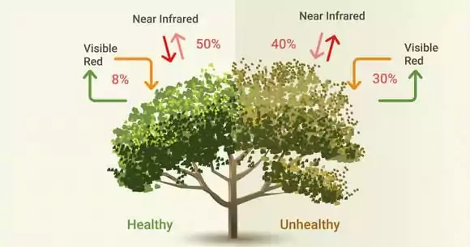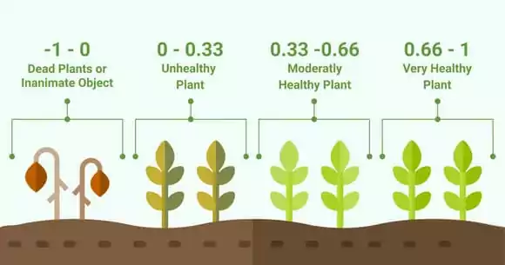

**NDWI**

NDWI (Normalized Difference Water Index) measures moisture content and detects water bodies using the GREEN-NIR combination.

Formula: NDWI = (Green - NIR) / (Green + NIR)

Positive values indicate water features, while negative values (or zero) indicate non-aqueous surfaces.

Ranges:

- 0.2 to 1: Water surface

- 0.0 to 0.2: Flooding or high humidity

- -0.3 to 0.0: Moderate drought or non-aqueous surfaces

- -1 to -0.3: Severe drought or areas without water.

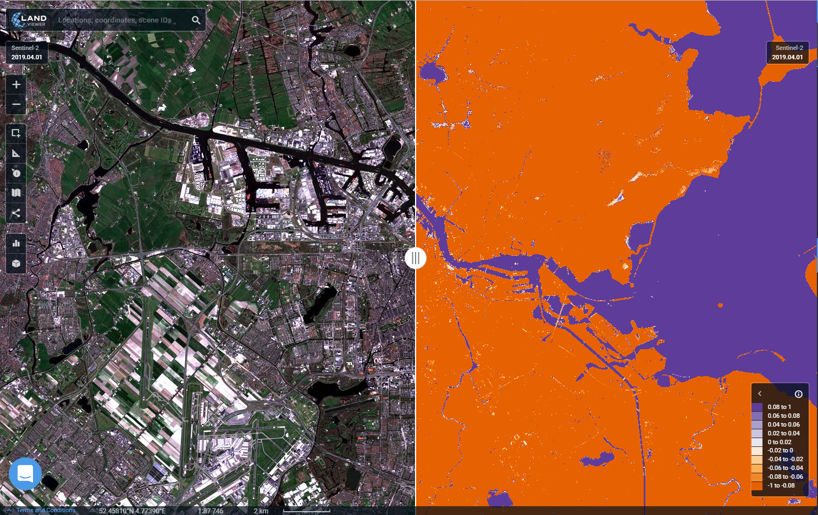

**MVI**

The Mangrove Vegetation Index (MVI) is a specific vegetation index used to assess the health and density of mangrove ecosystems.Positive values indicate healthy and dense mangrove vegetation, while negative values suggest stressed or sparse mangrove cover. MVI helps monitor mangrove health and supports conservation efforts for these critical coastal habitats.

The formula for the Mangrove Vegetation Index (MVI) is as follows:

MVI = (NIR - Green) / (SWIR - Green)

**SAVI**

SAVI (Soil-Adjusted Vegetation Index) is a vegetation index used in remote sensing. It corrects for soil brightness, providing more accurate assessments of vegetation cover. Positive values indicate healthy vegetation, while values close to 0 suggest stressed or sparse vegetation. SAVI is useful in diverse landscapes and various applications, including agriculture, forestry, and environmental monitoring.

The formula for the Soil-Adjusted Vegetation Index (SAVI) is as follows:

SAVI = ((NIR - Red) / (NIR + Red + L)) * (1 + L)

where:

NIR = Near-Infrared band reflectance

Red = Red band reflectance

L = A constant parameter (usually set to 0.5) to adjust for soil brightness.

**EVI**

EVI stands for the Enhanced Vegetation Index. It is an improved vegetation index used in remote sensing to assess vegetation health and density. EVI builds upon the limitations of traditional vegetation indices like NDVI (Normalized Difference Vegetation Index) by taking into account factors like the canopy background and aerosol scattering, resulting in a more accurate representation of vegetation cover, particularly in areas with dense canopies or atmospheric interferences.

The formula for the Enhanced Vegetation Index (EVI) is as follows:

EVI = 2.5 * ((NIR - Red) / (NIR + 6 * Red - 7.5 * Blue + 1))

where:

NIR = Near-Infrared band reflectance

Red = Red band reflectance

Blue = Blue band reflectance

EVI values typically range from -1 to +1, with the following interpretations:

- Positive values: Indicate healthy and dense vegetation cover.

- Values close to 0: Suggest moderate vegetation or sparse vegetation.

- Negative values: Generally represent non-vegetated areas or surfaces

**Machine Learning Models**

Certainly! Let's focus on the machine learning models related to mangrove cover change:

1. Linear Regression:

- Linear regression can be used to analyze the trend and rate of change in mangrove cover over time.

- It helps estimate the increase or decrease in mangrove area and identify factors influencing the change.

2. Random Forest:

- Random forest can be applied for mangrove cover change detection and classification.

- It helps identify areas where mangrove cover has changed, distinguishing between areas of growth, decline, or stability.

3. ARIMA (AutoRegressive Integrated Moving Average):

- ARIMA can be utilized to forecast future mangrove cover change based on historical time series data.

- It helps predict potential trends and patterns in mangrove cover, aiding in proactive conservation planning.

4. SARIMA (Seasonal AutoRegressive Integrated Moving Average):

- SARIMA can be used to account for seasonal variations in mangrove cover change, considering cyclical patterns caused by environmental factors.

- It improves the accuracy of forecasting mangrove cover changes, especially in seasonal ecosystems.

5. LSTM (Long Short-Term Memory):

- LSTM can be employed to capture complex temporal dependencies and long-term patterns in mangrove cover change.

- It enables accurate predictions of mangrove cover change over extended periods, considering historical time series data.

**4. DESIGN**

The project follows a systematic approach to analyze mangroves in Gujarat. It involves the following steps:

1. Data Acquisition: Satellite imagery and relevant datasets are collected.

2. Pre-processing: Atmospheric correction and image registration techniques are applied to enhance data quality.

3. Mangrove Classification: Advanced algorithms and techniques are used to classify mangrove vegetation.

4. Statistical and Spatial Analysis: Various statistical and spatial analysis methods are employed to study the health and changes in mangrove vegetation.

5. Data Visualization: The results are presented through interactive visualizations to facilitate better understanding and interpretation.

The design ensures a comprehensive and structured methodology for analyzing and interpreting mangrove data in Gujarat.

**Workflow:**

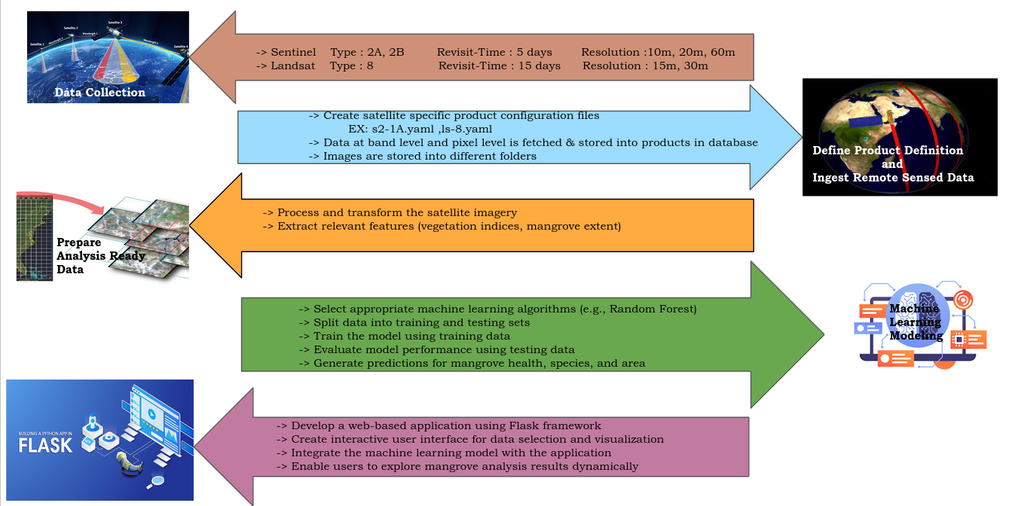

**5. FLASK APPLICATION**

Flask provides the essential tools for creating a web application that visualizes and analyzes remote sensing data to monitor mangrove changes in Gujarat. It enables user interactions, data access, and machine learning analysis, all while offering a scalable and user-friendly solution.

**1. Web Framework:** Flask serves as the web framework for your project, enabling the development of web applications.

**2. Data Visualization:** Flask is used to create interactive and user-friendly visualizations of remote sensing data related to mangroves.

**3. Data Loading:** Flask handles the loading and retrieval of satellite data from the data cube for analysis.

**4. Leaflet Map Integration:** Flask integrates the Leaflet map API to allow users to select specific mangrove areas for analysis.

**5. Machine Learning Analysis:** Flask facilitates the use of machine learning algorithms (e.g., random forest, LSTM) to analyze mangrove changes.

**6. RESTful API:** Flask can create RESTful APIs for data access, enabling seamless integration with other systems or services.

**7. Scalable Solution:** Flask's minimalistic design ensures a scalable and efficient web application for monitoring mangrove changes.

**8. Deployment:** The Flask application can be easily deployed on various production servers using WSGI-compliant options like Gunicorn or uWSGI.

**6. UI**

**User Interaction:**

Users interact with the web application by selecting a specific area on the map and choosing a date range for analysis. They can also select the vegetation index (NDVI or MVI) to analyze.

**Data Loading and Processing:**

When the user submits the form, the Flask backend receives the input data. The Datacube library is used to load satellite data for the selected area and time range. The data is processed, and the selected vegetation index is calculated.

**Analysis and Visualization:**

The calculated index values are analyzed to assess the health and changes in mangrove vegetation. The results are visualized through charts and images. The charts show the trends of vegetation indices over time, providing insights into mangrove vegetation dynamics. Images represent the analyzed area and are displayed to the user.

**Data Presentation:**

The processed data, analysis results, and visualizations are sent back to the front end as a JSON response. The front end receives this data and dynamically updates the UI, displaying the charts, images, and relevant information about the analyzed area.

**7. SCREENSHOTS**

* User view

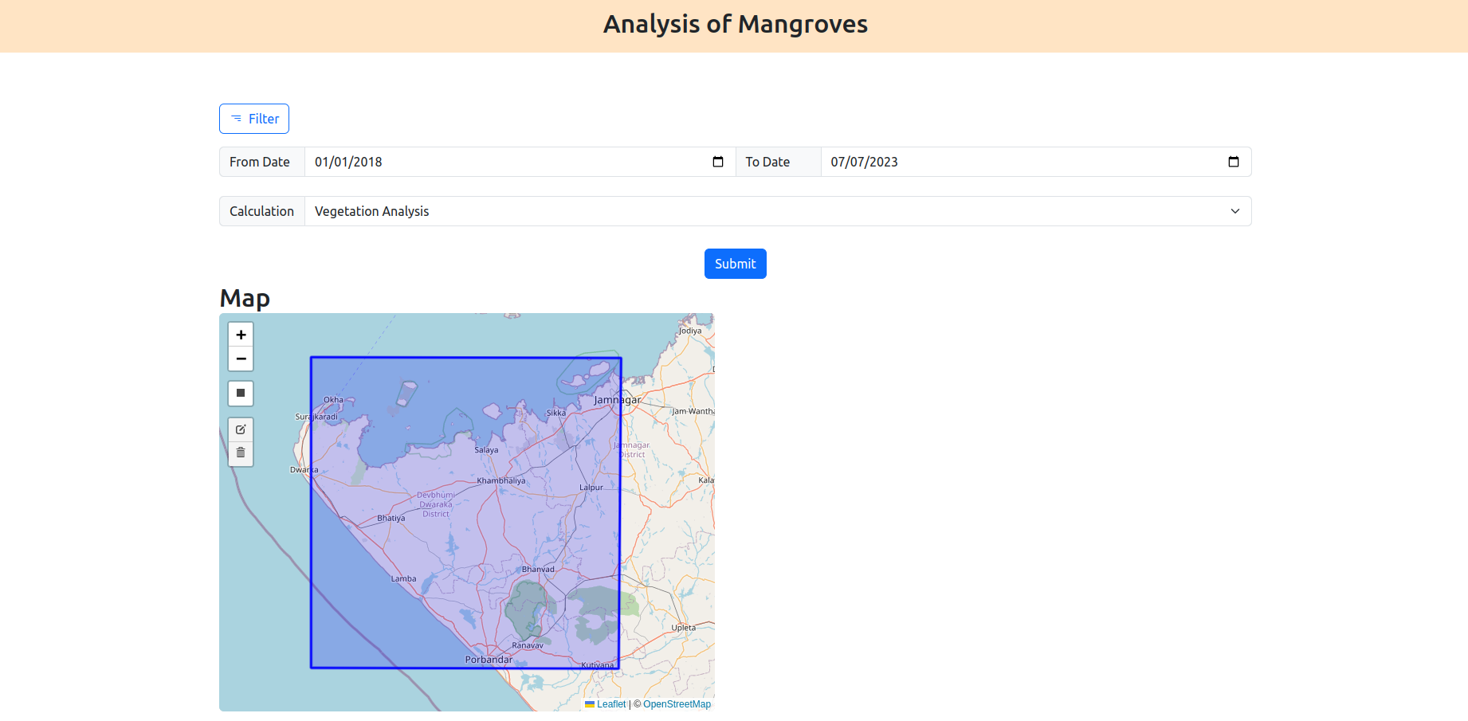

* User selects a type

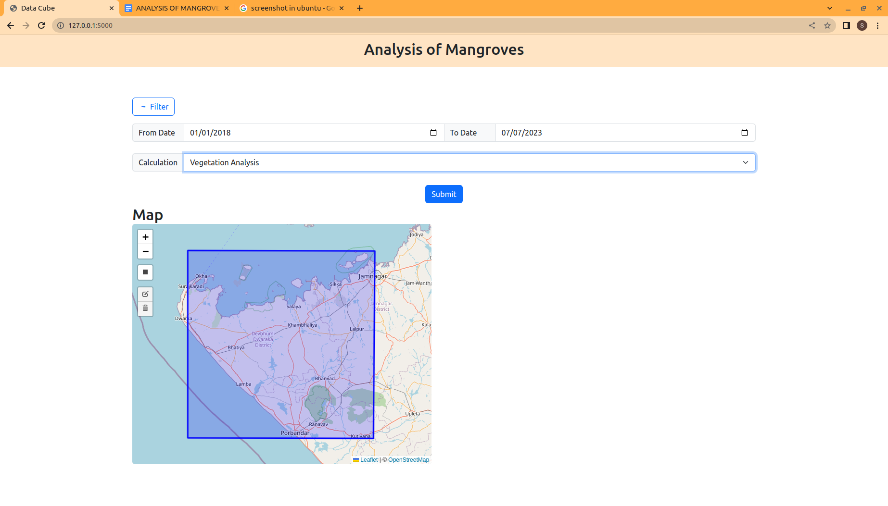

* Click on rectangle draw handler icon to select an area

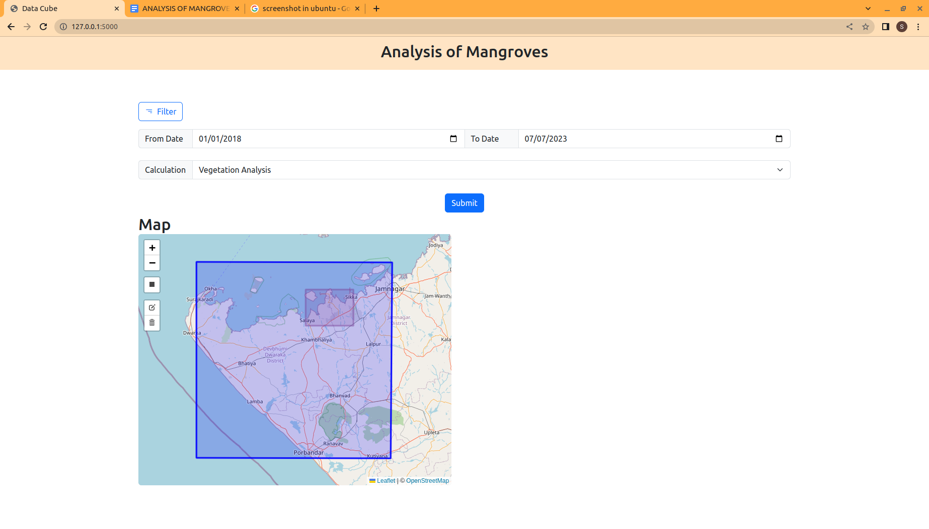

* As the user selects an area the plot, chart and predictions are shown

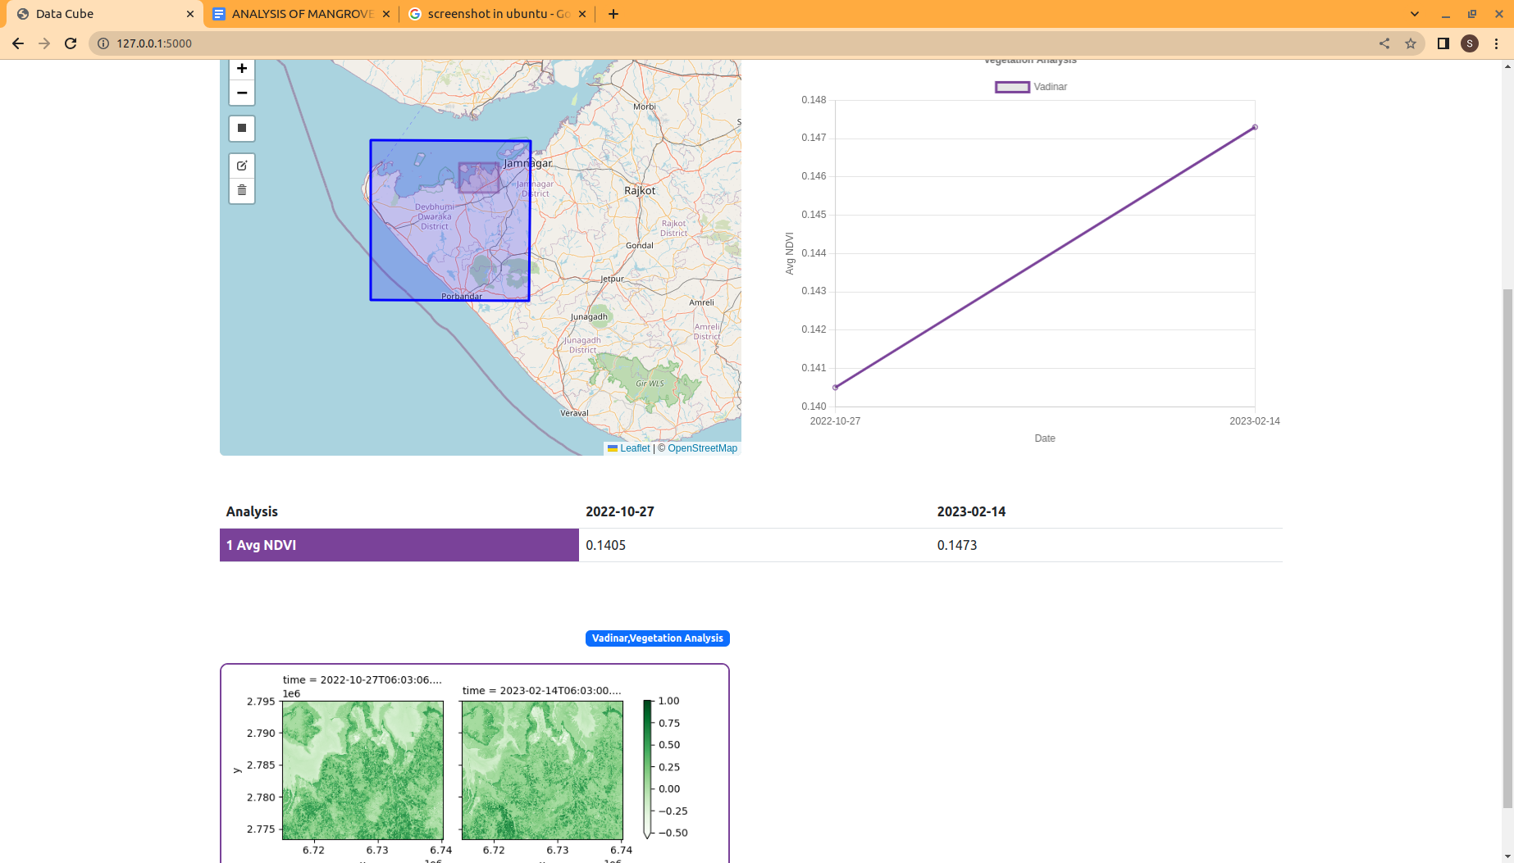

**8. CONCLUSION**

The Analysis of Mangroves in Gujarat project represents a significant step towards leveraging cutting-edge technologies for environmental monitoring and conservation. By combining machine learning, the Flask framework, and web development technologies, the project offers a robust platform to analyze and monitor mangrove vegetation using satellite data.

The web application's user-friendly interface allows users to interactively explore the data and visualize the results, providing valuable insights into the health and dynamics of mangrove ecosystems in the Gujarat region. The ability to select specific areas, date ranges, and vegetation indices enhances the project's versatility and applicability for diverse research and conservation needs.

The integration of machine learning algorithms elevates the project's analytical capabilities, enabling accurate predictions and trend analysis of mangrove vegetation changes over time. This feature has immense potential in guiding conservation efforts and decision-making for sustainable mangrove management.

By effectively bridging the gap between data analysis and user experience, the project fosters greater engagement and understanding among stakeholders.

In conclusion, the Analysis of Mangroves in Gujarat project is a compelling example of how advanced technologies can be harnessed to protect and preserve critical coastal ecosystems. With its user-friendly interface and powerful analytical tools, the project offers a valuable resource for environmental researchers, policymakers, and conservationists working towards the long-term health and sustainability of mangrove habitats in Gujarat and beyond.

**9. BIBLIOGRAPHY**

Information for this project is gathered from google and from these following websites:

1. <https://docs.digitalearthafrica.org/en/latest/sandbox/notebooks/Real_world_examples/index.html>
2. <https://datacube-core.readthedocs.io/en/latest/about-core-concepts/index.html>
3. <https://gisgeography.com/how-to-download-sentinel-satellite-data/>
4. <https://opensourceoptions.com/blog/remote-sensing-with-qgis-calculate-ndvi/>
5. <https://gisgeography.com/usgs-earth-explorer-download-free-landsat-imagery/>
6. <https://earthexplorer.usgs.gov/>
7. <https://scihub.copernicus.eu/dhus/#/home>
8. <https://gisgeography.com/sentinel-2-bands-combinations/>
9. <https://docs.dea.ga.gov.au/notebooks/Beginners_guide/08_Intro_to_xarray.html>
10. <https://explorer.digitalearth.africa/products>
11. <https://www.youtube.com/watch?v=iYyN5PWu4NQ>
12. <https://youtu.be/MKpp7GYBc5U>
13. <https://drive.google.com/file/d/1fAeKrWOLze6qjp5pipVVq9Wuspb9o1m8/view?usp=sharing>
14. <https://www.opendatacube.org/>
15. <https://www.hostinger.in/tutorials/how-to-install-postgresql-on-ubuntu/>
16. <https://www.digitalocean.com/community/tutorials/how-to-make-a-web-application-using-flask-in-python-3>
17. <https://flask.palletsprojects.com/en/2.3.x/quickstart/>
18. <https://apps.sentinel-hub.com/sentinel-playground/?source=S2L2A&lat=40.4&lng=-3.730000000000018&zoom=12&preset=1_TRUE_COLOR&layers=B01,B02,B03&maxcc=20&gain=1.0&gamma=1.0&time=2023-01-01%7C2023-07-17&atmFilter=&showDates=false>
19. <https://sentinel.esa.int/documents/247904/685211/Sentinel-2-MSI-L2A-Product-Format-Specifications.pdf>
20. <https://docs.sentinel-hub.com/api/latest/data/sentinel-2-l2a/>
21. <https://www.opendatacube.org/overview>
22. <https://machinelearningmastery.com/make-predictions-time-series-forecasting-python/>
23. <https://towardsdatascience.com/introduction-to-arima-for-time-series-forecasting-ee0bc285807a>
24. <https://towardsdatascience.com/time-series-forecasting-with-arima-sarima-and-sarimax-ee61099e78f6>

GitHub link - [www.github.com/srinith2710/Analysis-of-Mangroves](http://www.github.com/srinith2710/Analysis-of-Mangroves)